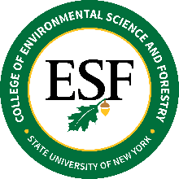
BOARD OF TRUSTEES
Sustainable Finance Committee Meeting
April 13, 2023 – 11:00 AM

A G E N D A

Call to Order

- Approval of Minutes from the February 22, 2023 Meeting
- Review of College Finances
  - Review of Information Technology (IT) Services received from Syracuse University under the Services Agreement expiring on May 13, 2024 (see Services Agreement, Section 7) during the 2021-22 and 2022-23 Academic Years
  - Overview of IT Services received from SUNY and ESF’s own IT Services
  - Discussion of Optimal Mix of IT Services from SU, SUNY, and ESF IT Services Unit
  - CFO Update on 2022-23 Academic Year Financial Results
  - CFO Update on Planning Underway for 2023-24 Academic Year Budget
- Discussion of Committee Recommendations Regarding College Finances
  - Discuss Option of Migrating Academic Registration Portal from MySlice to ESF Student Registration Portal
- Committee Meeting Schedule
- New Business
Adjournment

